Task 2.5:

Questions:

1. In your own words, explain Django static files and how Django handles them.
Static files in Django are files like JavaScript, CSS or images that do not change on the web app and are fixed which are used to render a complete web app mainly used to customize the apps look a feel.

Ans: Django utilizes many dynamic files such as templates that are prone to change when required. But there are some files that are not dynamic and stay the same. Those files are called static files. These may include files like images, CSS, JS files. We can use these files by loading the static files directory and then referencing them wherever they are needed in the templates.

2. Look up the following two Django packages on Django’s official documentation and/or other
trusted sources. Write a brief description of each.

Ans:

- ListView: When using Class-based views in our Django project we can use this view to make a page that displays a list of objects. We can specify the model in the view class and objects of that model will be displayed in a page made by this class.

- DetailView: This is another view class that is responsible for displaying just a single item from a table/model. We can take the required parameter for selection of the item in the url.

Front-end Inspirations

Following are the websites that I liked and I am using as the inspiration for my own frontend.

1. cinc

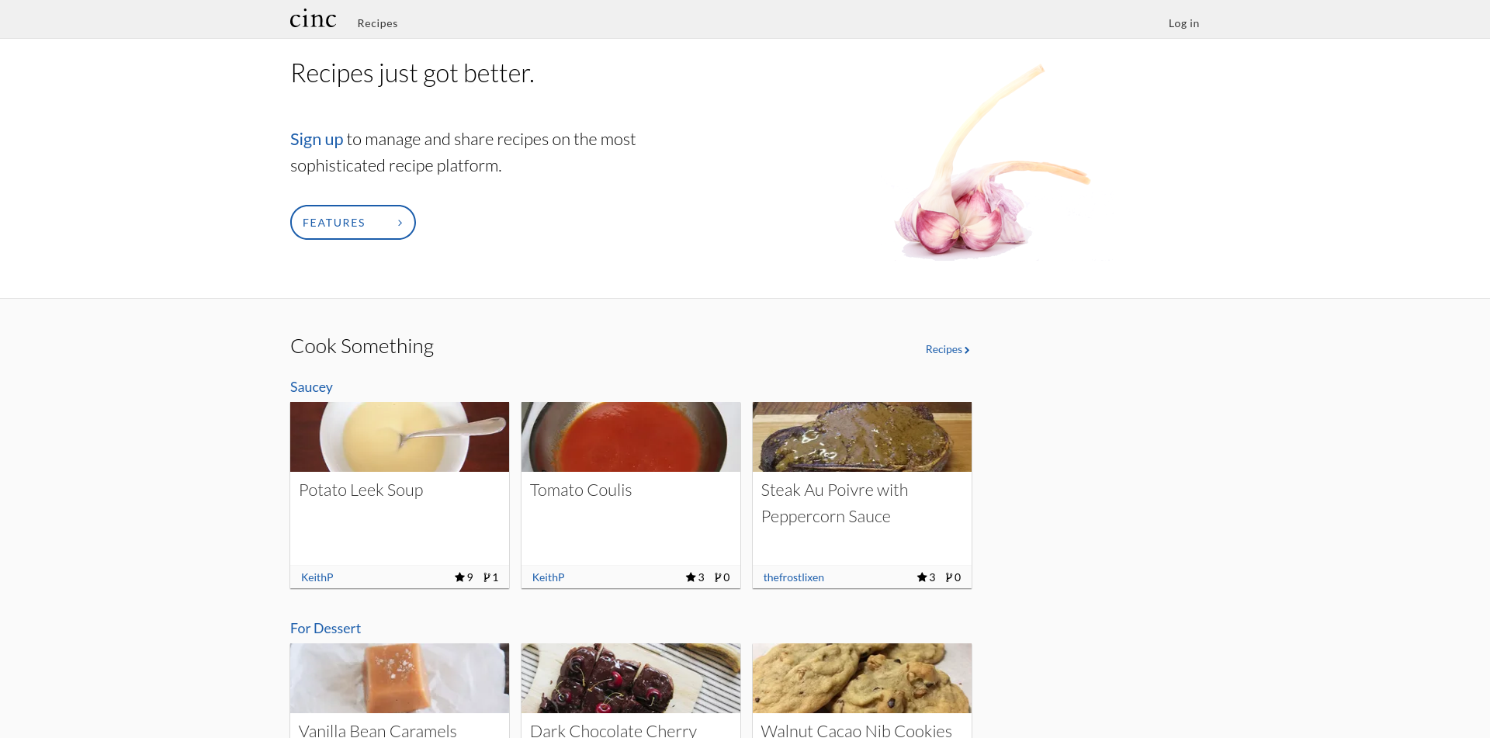
The design of this website is very simple and minimalist while still having all the necessary features that a recipe web app should have.

2. Noodles

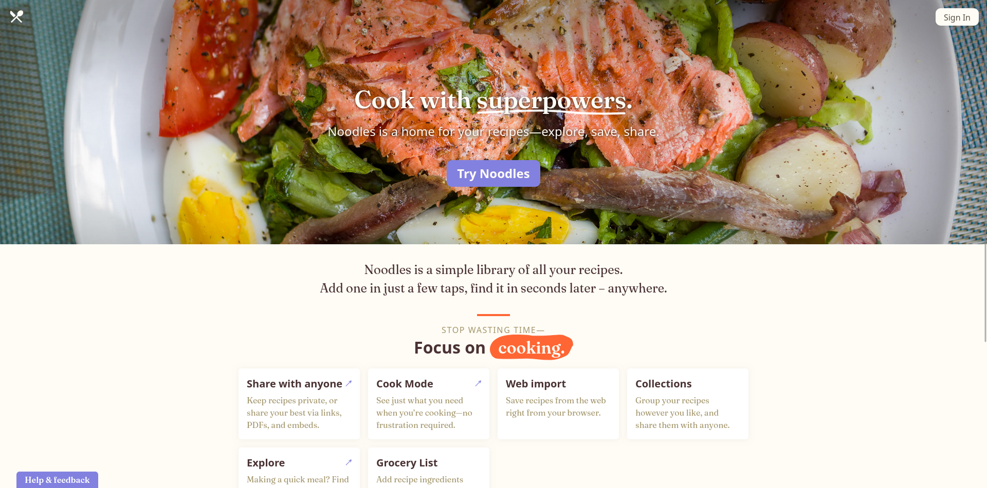
.
This web app has a simple and clean design but the use of the colour theme makes it really attractive for visitors to stop and explore what this website has to offer.
3. Cookbook

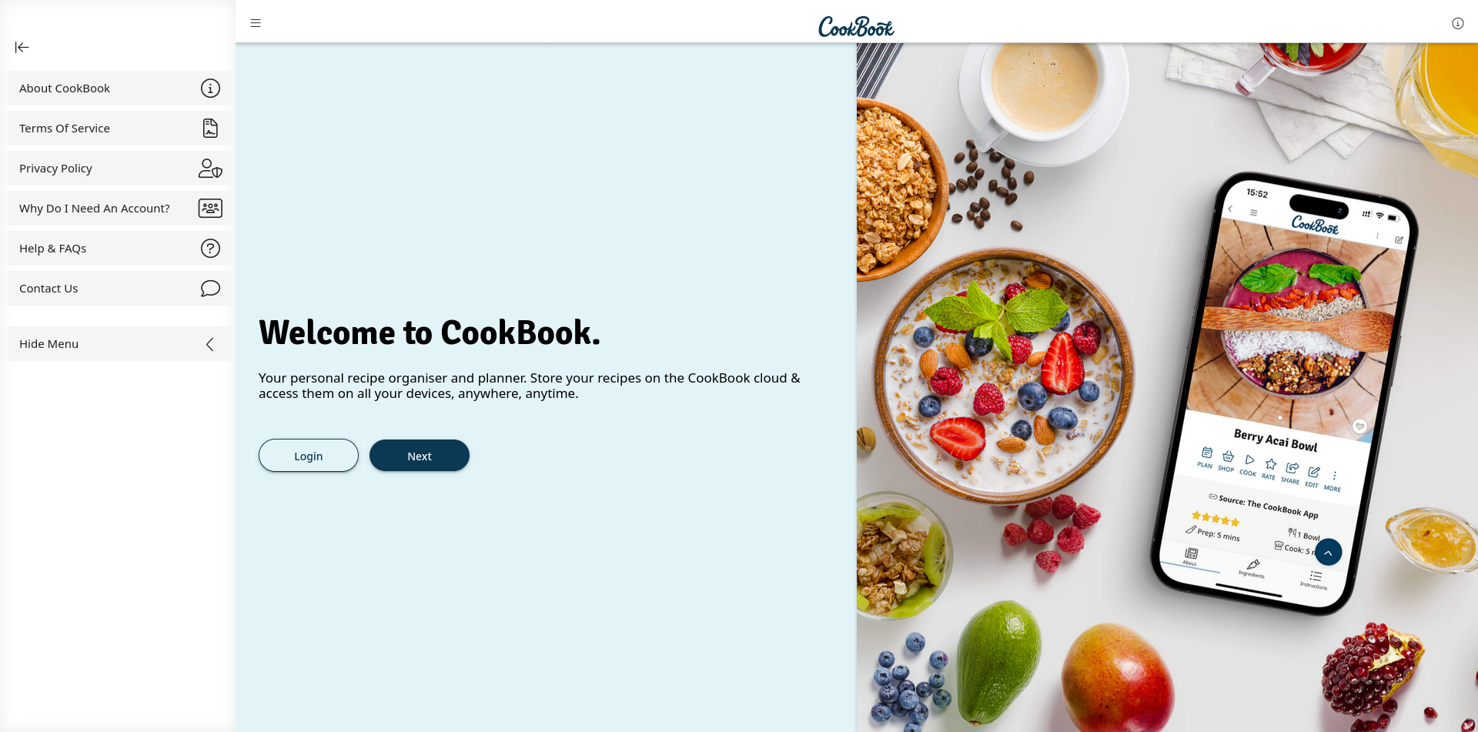

This is another recipe app that I like. The sidebar in this app is the main attraction as it is more pleasing and natural to use then a navigation menu on the top.

